

In above image Textbox Error is not shown in a proper way. Cannot understanding which box empty or which box is is to be filled.

In Above Image Here uploading/Drag Drop option is not given For photo and signature.



In Above Image Phone number validation is not there.

For mobile number field there is no any separate country code.

In Above Image Here size of Textbox is not same as to other textbox And UI is not user friendly.



In above Image Placeholder is not there for understanding. Dropdown box size for all fields is not same.

In above Image Here there is no space in between radio buttons.

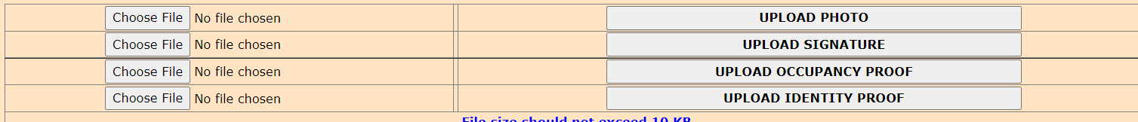

Uploading of documents is not properly working